Sample support plan adapted to the work context

Form 1: Blank form

Complete the blank spaces on the axes of the graph writing in the areas in which the person needs support (add other axes as necessary). Grade the intensity of support from 0 to 10 (Support score) in each case (0 equalling no support and 10 maximum intensity of support). Then join up the dots marking the intensity on every axis to obtain the diagram of the individual's support plan.
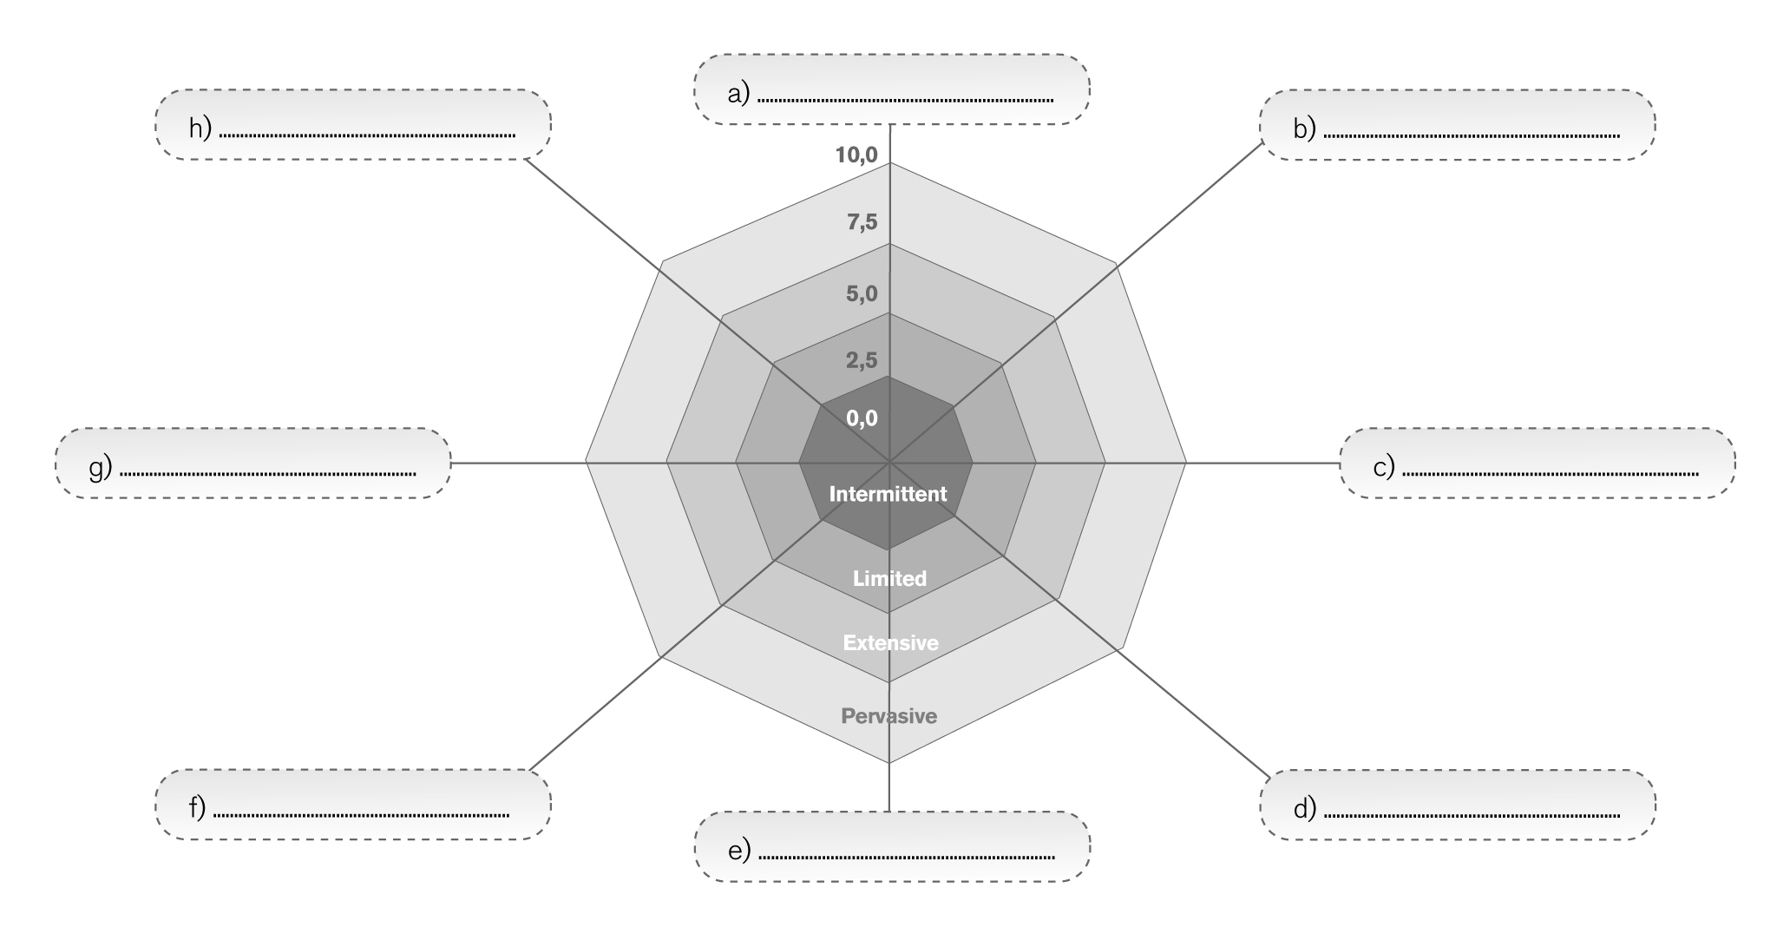

Scope of support | Description of support (intensity, frequency, duration, provider, etc.) | Date (start-finish) | Support score
a)
b)
c)
d)
e)
f)
g)
h)

Date:.………………………………………………………………………………………………………………………

Prepared by:. …………………………………………………………………………………………………………

Types of support (depending on the combination of frequency, intensity, duration and scope):

- Intermittent: support is provided sporadically and episodically, when needed, and is infrequent. It is more or less intense, depending on the setting, preferably outside the working environment.

- Limited: support is provided periodically, consistently and over limited periods; it is variable in intensity and provided in some of the settings, preferably outside the working environment.

- Extensive: support is consistent and time-unlimited; its frequency ranges from medium to high, and is fairly intense; it is provided in more than one environment, including work.

- Pervasive: support is continuous and stable; with great frequency and intensity; it is provided in most settings, especially in the working environment.

Form 2: Completed sample of a Support plan adapted to the work context

Sample case

Complete the blank spaces in the axes of the graph writing in the areas in which the person needs support (add other axes as necessary). Grade on a scale from 0 to 10 the degree of support (support level) in each case (0 equalling no support and 10 maximum intensity of support). Then join up the dots marking the intensity on every axis to obtain the diagram of the individual's support plan.

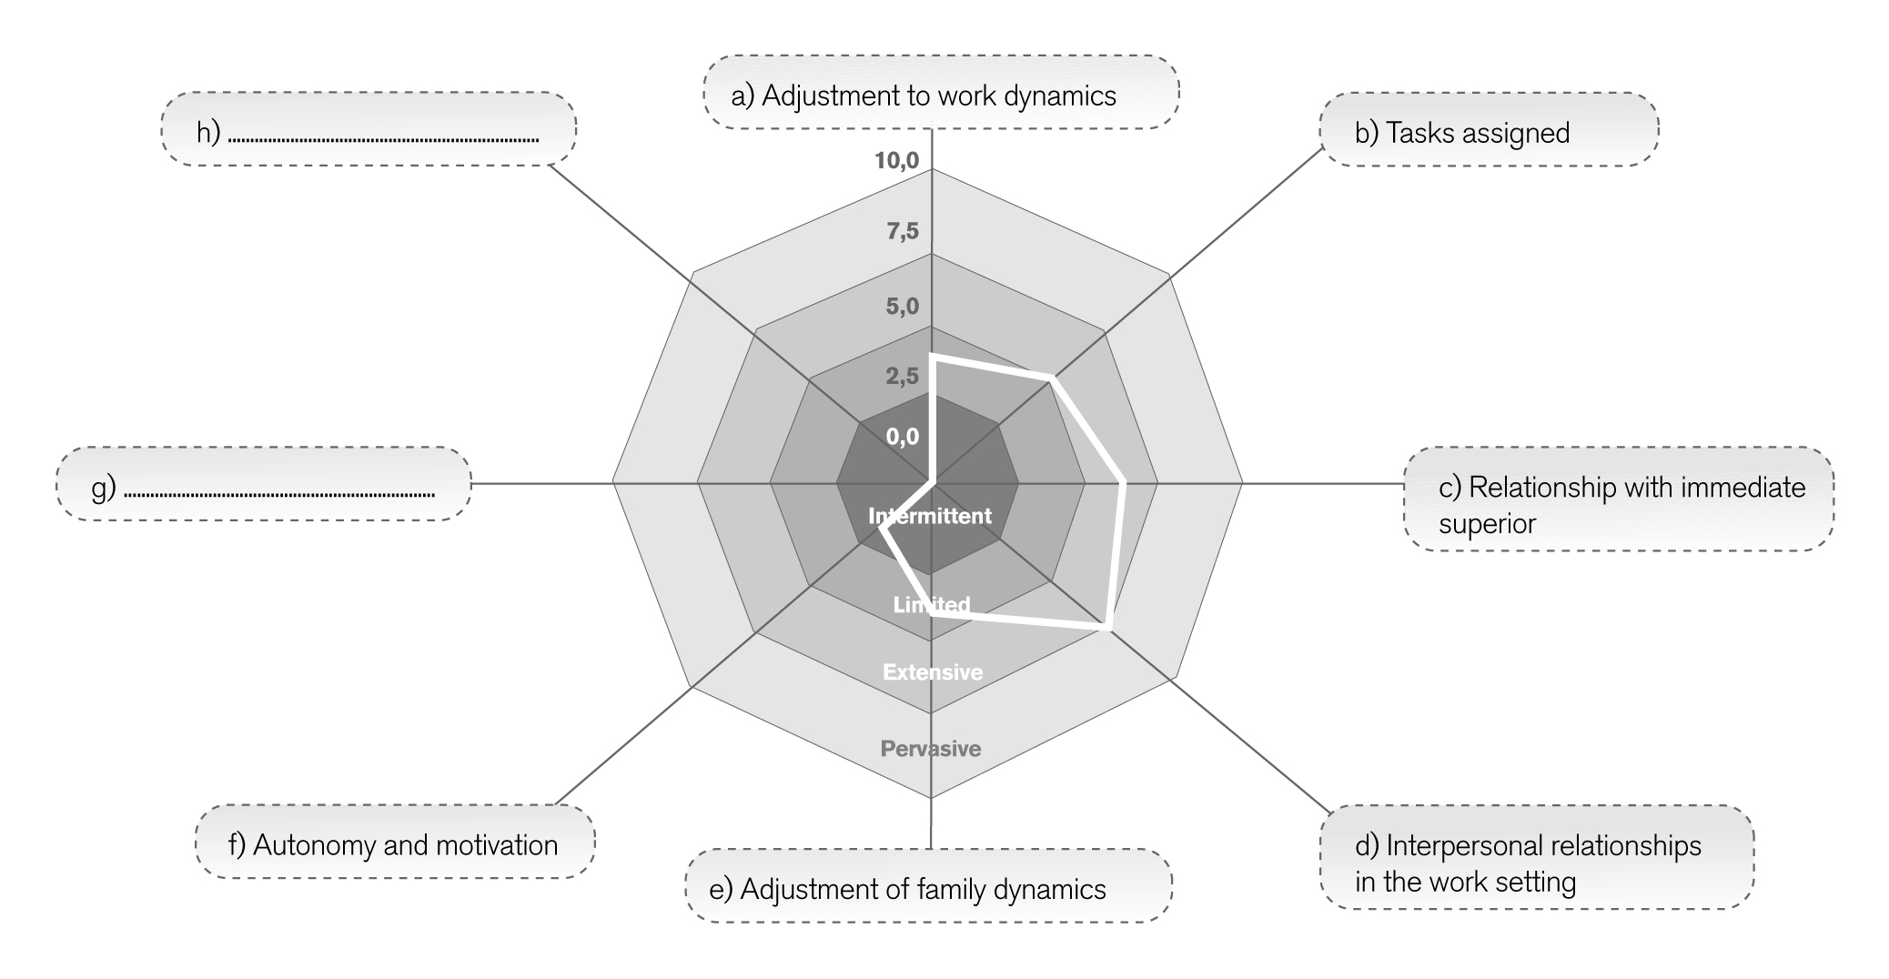

Scope of support | Description of support (intensity, frequency, duration, provider, etc.). | Date (start-finish) | Support score
a) Adaptation to the dynamics of the work situation (time management.) | Laura has not worked for a long time. Therefore, support is recommended for adapting to the new timetables that the job requires and the way this affects how she organises her time. She will need limited support (4) during the adjustment period to cope with the changes that work involves in organising her time so that this does not become a "problem" for her to continue working. | From the start of the job and until she adapts to the schedule (2 months approximately). | 4,0
b) Tasks assigned | Laura is familiar with the tasks assigned to her as a result of previous experience in similar posts. However, she finds certain tasks that entail greater responsibility more interesting than others. Help Laura to cope with those tasks that are of little interest, encourage creativity and cope with the "routine tasks" of the job. Extensive support (5) consists of working on the target tasks, fostering her creativity and transforming them into her own areas of responsibility which have a value for her and for the organisation. | From the moment she starts the job and without a time limit (reassess after the first 6 months) | 5,0
c) Relationship with immediate superior | Bearing in mind the previous difficulties for job retention, extensive support is recommended (6) as regards the relationship with the shop manager. This support will be linked mainly to everyday contact, the tasks allotted and resolving situations of conflict that arise because of tasks that Laura does not like or have negative connotations within the work environment (for example, tasks for “the new employees”, etc.). Help to establish a "transparent" relationship, without double meanings that cause mutual distrust. | From the moment she starts the job and without a time limit (reassess after the first 6 months) | 6,0
d) Interpersonal relationships in the work environment | Laura will need a certain amount of time to become familiar with the work environment, the predominant atmosphere in social relationships, power relations, etc.  Because of her character and previous history of interpersonal conflicts in the workplace, extensive support (7.5) is advisable, on a regular basis outside the workplace and supplemented with follow-up in the company.  This support is geared towards understanding interpersonal relationships that arise and thinking before acting to avoid undesirable consequences that make it difficult to remain in the post. | From the moment she starts the job and without a time limit (reassess after the first 6 months) | 7,5
e) Adapting the dynamics of family life | Laura's unemployment resulted in a series of domestic and family activities that will have to be reorganised. In this regard, Laura will need limited support (4) to organise re-allotting tasks to do with her household situation and managing situations as a result of her change of role. Take into account the gender roles in the household environment and the effect that a double or triple workload might have on Laura as she takes on multiple tasks and responsibilities, and the effect on the tiredness that she manifests. | From the start of the job and until she adapts to the schedule (3 months approximately). | 4,0
f) Autonomy and motivation | Laura is a very autonomous person. However, she will require intermittent support (2) at certain levels of autonomy and in mastering certain responsibilities that may create a stress overload in her. Nevertheless, these responsibilities encourage motivation and interest in the post, and therefore, it is worth working on them. | From the start of the job and depending on need. | 2,0
g)
h)

Observations: The axes Autonomy and motivation, and Tasks assigned could generate another working approach regarding the routine aspects of the post. Assess whether to propose another specific work axis on this subject in order to work on it directly.

Date: .... March 2011 ..........................................

Prepared by: C.F. ..........................................................

Kinds of support (depending on the combination of frequency, intensity, duration and scope):
- Intermittent: support is provided sporadically and episodically, when needed, and is infrequent. It is more or less intense, depending on the setting, preferably outside the working environment.

- Limited: support is provided periodically, consistently and over limited periods; it is variable in intensity and provided in some of the settings, preferably outside the working environment.

- Extensive: support is consistent and time-unlimited; its frequency ranges from medium to high, and is fairly intense; it is provided in more than one environment, including work.

- Pervasive: support is continuous and stable; with great frequency and intensity; it is provided in most settings, especially in the working environment.

Adapted from Clarke, S., Sanderson, H., & Bamber, C. (2006). Life and support Plan, A guide for Individual Budget Pilot Sites. U.K.: Individual Budgets Pilot Programme. Care Services Improvement Partnership. Department of Health, Office of the Deputy Prime Minister, Office for Disability Issues and the Department for Work and Pensions.
Adapted from Clarke, S., Sanderson, H., & Bamber, C. (2006). Life and support Plan, A guide for Individual Budget Pilot Sites. U.K.: Individual Budgets Pilot Programme. Care Services Improvement Partnership. Department of Health, Office of the Deputy Prime Minister, Office for Disability Issues and the Department for Work and Pensions.

