Work behaviour inventory

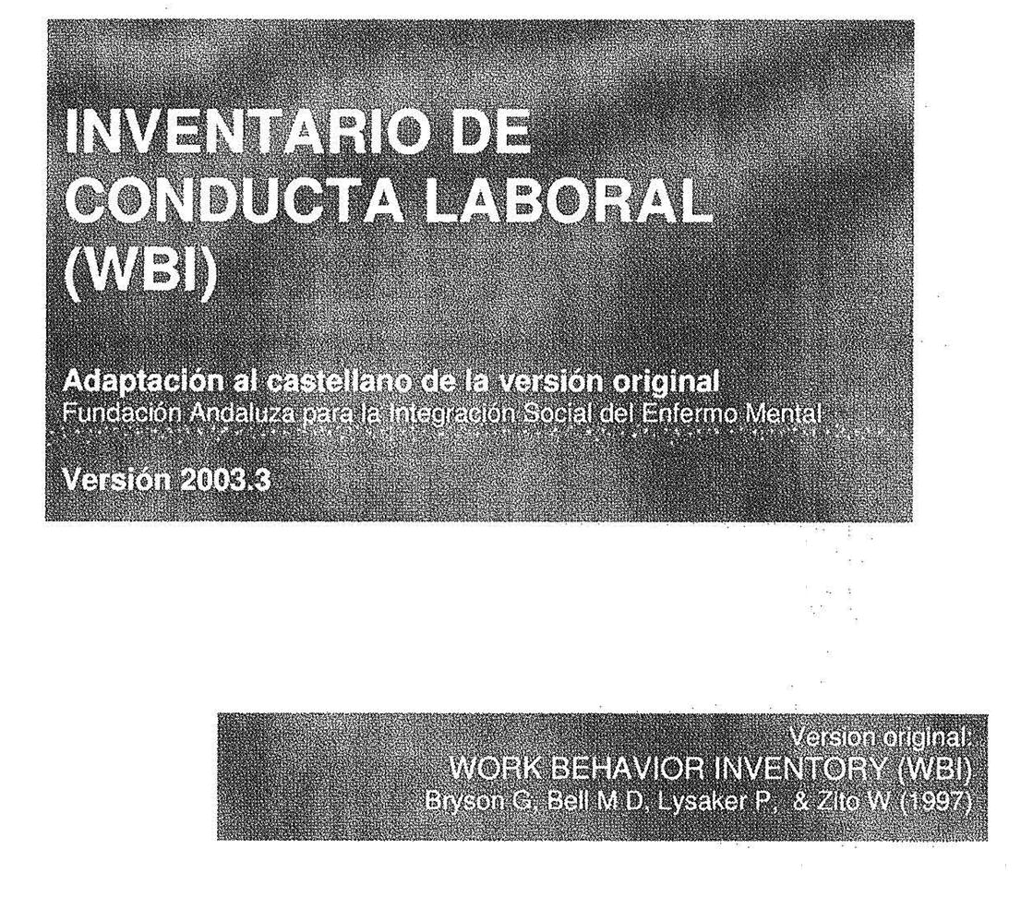
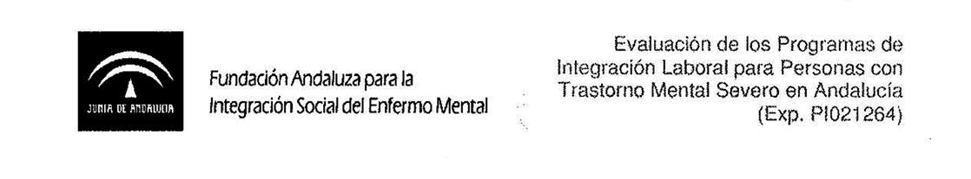

Description and Aims

The Work Behavior Inventory has been adapted to Spanish from the Work Behavior Inventory (WBI), a short scale that rates work functioning and has been specifically designed for use with individuals who suffer severe mental health condition in employment integration projects.

It consists of 5 areas, each comprising 7 items, plus a global item reflecting the overall assessment.

Instructions

To complete the scale, an evaluator must interview the person responsible for the client being assessed (monitors in occupational workshops, supervisors in social enterprises and monitors in vocational occupational training). Scores are to be awarded in accordance with the instructions provided below.

The questions asked of the informant should refer to a period no longer than the two weeks prior to the interview.

Each item must be scored from one to five:

- 5 = area of superior performance in the majority of cases.
- 4 = area of superior performance in some cases.
- 3 = adequate performance in this area.
- 2 = area for improvement in some cases.
- 1 = area for improvement in the majority of cases.

In general, conduct should be considered “superior performance” when the behaviour observed is extremely valuable in competitive employment; “needs to improve” if it reflects a minimum behaviour required in competitive employment and “adequate performance” when the behaviour could not be considered either valuable or minimum in competitive employment.

It is particularly important that the assessment carried out with the WBI are conducted bearing in mind at all times the performance level expected in an ordinary work context.

The interview with the supervisor should include the following general questions:

- “How well does (the participant) do his/her work?”
- “What are his/her strengths and weaknesses as a worker?”

When necessary, more specific questions should be asked with the aim of scoring each item on the scale accurately.

Furthermore, with time the supervisors may tend to answer simply "No change” regarding certain participants. In such cases it is useful to ask questions such as:

- “Has the participant shown any improvement lately?” “Are there any areas where his/her work behaviour could improve?”
Basic scoring principles

- Remember that the levels of response on the scale refer to the frequency with which difficult or noteworthy behaviours occur and not to the severity or the intensity thereof.
- If two levels of response can be selected in an item, the lower must be chosen.
- It needs to be borne in mind that some items, by their very definition, limit the range of responses that can be selected. For example, a participant that shows a severely blunted affect could never score above 3 in item E1: “doesn't become nervous or aggressive.” In this case, it is true that the person does not become nervous or aggressive, but the reason for this behaviour is that in fact he/she lacks emotional reactivity. His/her behaviour cannot be rated as an area worthy of note.
- When an item does not seem to be applicable or we have not gathered sufficient information to be able to score it, a score of 3 must be given.
- A score of 5 must be reserved only for work behaviour that stands out as superior in the context of competitive work.

Name of user: |  | Code:
Service: |  | Code:
Name of informant: |  | Code:
Name of Interviewer: |  | Code:
Date of interview:

Scale A: Social skills
A1 | Does not seem too distant or withdrawn | 1 | 2 | 3 | 4 | 5
A2 | Seems at ease when others approach | 1 | 2 | 3 | 4 | 5
A3 | Likes to socialise whenever he/she can | 1 | 2 | 3 | 4 | 5
A4 | Seems interested in others | 1 | 2 | 3 | 4 | 5
A5 | Expresses positive feelings in an appropriate manner | 1 | 2 | 3 | 4 | 5
A6 | Has a positive relationship with work mates | 1 | 2 | 3 | 4 | 5
A7 | Expresses negative feelings in an appropriate manner | 1 | 2 | 3 | 4 | 5

Scale B: Cooperation
B1 | Works comfortably in the presence of others | 1 | 2 | 3 | 4 | 5
B2 | Accepts constructive criticism without showing anger | 1 | 2 | 3 | 4 | 5
B3 | Listens closely to instructions | 1 | 2 | 3 | 4 | 5
B4 | Follows the instructions received without resistance | 1 | 2 | 3 | 4 | 5
B5 | Listens to instructions without interrupting | 1 | 2 | 3 | 4 | 5
B6 | Cooperates with workmates | 1 | 2 | 3 | 4 | 5
B7 | Asks when he/she doesn't understand something | 1 | 2 | 3 | 4 | 5

Scale C: Work Habits
C1 | Arrives at work on time | 1 | 2 | 3 | 4 | 5
C2 | Starts tasks promptly | 1 | 2 | 3 | 4 | 5
C3 | Follows the rules laid down for the job | 1 | 2 | 3 | 4 | 5
C4 | Only takes the official rest breaks | 1 | 2 | 3 | 4 | 5
C5 | Carries out his/her individual tasks in the time given | 1 | 2 | 3 | 4 | 5
C6 | Keeps up the pace of work once he/she gets going | 1 | 2 | 3 | 4 | 5
C7 | Shows initiative at work whenever possible | 1 | 2 | 3 | 4 | 5

Scale D: Quality of Work
D1 | Carries out work accurately | 1 | 2 | 3 | 4 | 5
D2 | Carries out work effectively | 1 | 2 | 3 | 4 | 5
D3 | The quality of products is satisfactory | 1 | 2 | 3 | 4 | 5
D4 | Searches out and identifies his/her own mistakes | 1 | 2 | 3 | 4 | 5
D5 | Does not need frequent encouragement | 1 | 2 | 3 | 4 | 5
D6 | Corrects his/her own mistakes | 1 | 2 | 3 | 4 | 5
D7 | Learns to do tasks in the time set | 1 | 2 | 3 | 4 | 5

Scale E: Personal Presentation
E1 | Does not become nervous or aggressive | 1 | 2 | 3 | 4 | 5
E2 | Does not seem to tire easily | 1 | 2 | 3 | 4 | 5
E3 | Avoids jokes or unsuitable humorous remarks | 1 | 2 | 3 | 4 | 5
E4 | His/her personal hygiene is satisfactory | 1 | 2 | 3 | 4 | 5
E5 | Comes to work suitably dressed | 1 | 2 | 3 | 4 | 5
E6 | Avoids making irrelevant comments | 1 | 2 | 3 | 4 | 5
E7 | Pays attention to the work | 1 | 2 | 3 | 4 | 5

Scale F: Global assessment of work behaviour
F1 | Overall score | 1 | 2 | 3 | 4 | 5

López, M., García-Cubillana, P., González, S., Fernández, L., Fernández, M., & Laviana, M. (2007) Adaptation and fidelity of the Spanish version of the Work Behavior Inventory in individuals with severe mental health conditions. Psychosocial rehabilitation, 4:1-10. Reprinted with the permission of the editors.
Area for improvement in the majority of cases
Area of superior performance in the majority of cases

